|  |
| --- |
| **18EES101J-BASIC ELECTRICAL AND ELECTRONICS ENGINEERING (LAB)** |
| **RECORD**  **SEMESTER I**    **ACADEMIC YEAR: 2020-21**  **NAME : *Tambe Utkarsh Yashwant.***  **REG. NO. : *RA2011027010166***  C:\Users\System 1\Desktop\11.png  **DEPARTMENT OF ELECTRICAL & ELECTRONICS ENGINEERING**  **FACULTY OF ENGINEERING & TECHNOLOGY**  **SRM INSTITUTE OF SCIENCE AND TECHNOLOGY**  (Formerly SRM University, Under section 3 of UGC Act, 1956)  **S.R.M. NAGAR, KATTANKULATHUR – 603 203**  **KANCHEEPURAM DISTRICT** |



**SRM Institute of Science and Technology**

(Deemed to be University)

**S.R.M. NAGAR, KATTANKULATHUR -603 203**

**KANCHEEPURAM DISTRICT**

**BONAFIDE CERTIFICATE**

**Register No : *RA2011027010166***

Certified to be the bonafide record of work done by *Tambe Utkarsh Yashwant* of *Computer Science & Engineering department*, B.Techdegree course in the Practical of 18EES101J Basic Electrical and Electronics Engineering in **SRM IST, Kattankulathur** during the academic year 2018-2019. **Lab in-charge**

**Date: Year Co-ordinator**

Submitted for end semester examination held in______________________ Lab, SRMIST**,** Kattankulathur**.**

**Date: Examiner-1 Examiner-2**

**LIST OF EXPERIMENTS**

1. Verification of Kirchhoff’s laws

2. Verification of All Theorems (Thevenin’s theorem, Norton’s theorem, Maximum power transfer theorem)

3. Transient analysis of RL an RC series circuits

4. Load test on single phase transformer

5. Demo of DC/AC machines & Parts

6. Types of wiring (fluorescent lamp wiring, staircase wiring)

7. Characteristics of semiconductor devices (PN junction, Zener diode, BJT)

8. Wave shaping circuits (Half and full wave rectifier, clipper)

9. Displacement measurement using LVDT and pressure measurement using Strain gauge

10. Verification and interpretation of Logic Gates.

11. Reduction of Boolean expression using K-map

12. Study of modulation and demodulation techniques.

**INDEX**

|  |  |  |  |
| --- | --- | --- | --- |
| **Sl. No.** | **Name of the Experiment** | **Marks (50)** | **Signature**  **of the Staff** |
| 1 | Verification of Kirchhoff’s laws |  |  |
| 2 | Verification of All Theorems  (Thevenin’s theorem, Norton’s theorem, Maximum power transfer theorem) |  |  |
| 3 | Transient analysis of RL an RC series circuits |  |  |
| 4 | Load test on single phase transformer |  |  |
| 5 | Demo of DC/AC machines & Parts |  |  |
| 6 | Types of wiring (fluorescent lamp wiring, staircase wiring) |  |  |
| 7 | Characteristics of semiconductor devices  (PN junction, Zener diode, BJT) |  |  |
| 8 | Wave shaping circuits  (Half and full wave rectifier, clipper) |  |  |
| 9 | Displacement measurement using LVDT and pressure measurement using Strain gauge |  |  |
| 10 | Verification and interpretation of Logic Gates. |  |  |
| 11 | Reduction of Boolean expression using K-map |  |  |
| 12 | Study of modulation and demodulation techniques. |  |  |

DEPT. OF ELECTRICAL & ELECTRONICS ENGINEERING

SRM INSTITUTE OF SCIENCE AND TECHNOLOGY, Kattankulathur – 603 203

|  |
| --- |
| Title of Experiment : **5. Demo of DC/AC machine & Parts.** |
| Name of the candidate : *Tambe Utkarsh Yashwant*.  Register Number : *RA2011027010166*  Date of Experiment : *31st October, 2020* |

|  |  |  |  |
| --- | --- | --- | --- |
| Sl.  No. | Marks Split up | Maximum marks  (50) | Marks obtained |
| 1 | Pre-Lab questions | 5 |  |
| 2 | Preparation of observation | 15 |  |
| 3 | Execution of experiment | 15 |  |
| 4 | Calculation / Evaluation of Result | 10 |  |
| 5 | Post-Lab questions | 5 |  |
| **Total** | | **50** |  |

**Staff Signature**

**PRE-LAB QUESTIONS**

**1. What are the major parts of the DC generators?**

**Ans : The major parts of the DC generators are :-**

***1. Stator -*** *The main function of the stator is to provide magnetic fields where the coil spins. A stator includes two magnets with opposite polarity facing each other. These magnets are located to fit in the region of the rotor.*

***2. Rotor -*** *A rotor in a DC machine includes slotted iron laminations with slots that are stacked to shape a cylindrical armature core. The function of the lamination is to decrease the loss caused due to eddy current.*

***3. Armature Windings -*** *Armature windings are in a closed-circuit form and are connected in series to parallel for enhancing the sum of produced current.*

***4. Yoke -*** *The external structure of the DC generator is known as Yoke. It is made of either cast iron or steel. It provides necessary mechanical power for carrying the magnetic-flux given through the poles.*

***5. Poles -*** *The function of a pole is to hold the field windings. These windings are wound on poles and are either connected in series or parallel by the armature windings.*

***6. Pole Shoe -*** *Pole shoe is mainly utilized for spreading the magnetic flux to avoid the field coil from falling.*

***7. Commutator -*** *A commutator works like a rectifier that changes AC voltage to DC voltage within the armature winding. It is designed with a copper segment, and each copper segment is protected from each other with the help of mica sheets. It is located on the shaft of the machine.*

***8. Brushes -*** *The electrical connections can be ensured between the commutator as well as the exterior load circuit with the help of brushes.*

**2. Give the classification of AC machines.**

**Ans :**

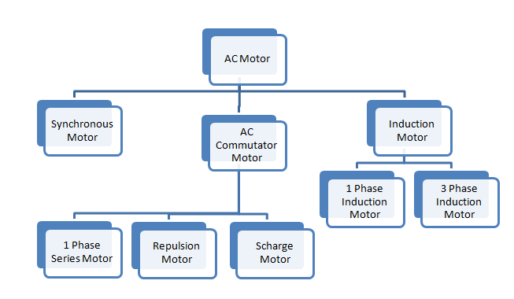

**3. What is the use of brushes in DC motor?**

**Ans : *A carbon brush*** *is a critical part of a dc motor, which relies on the brush for the transmission of electrical current coming from the machine’s rotating part. The brush is also responsible for changing the course of current in the conductors during the rotation process. The carbon brush also ensures the commutation of the current’s direction several times per rotation of the machine.*

**4. In a DC machine, rectification process is carried out in order to get unidirectional output (DC). This rectification process is carried out by** *Commutator.*

**5. Why the armature of DC motor is laminated?**

**Ans :** *These individual, thin pieces have a higher resistance than one solid piece, and therefore, produce less eddy currents and experience lower eddy current loss. The individual iron pieces that make up the armature are referred to as* ***laminations.***

|  |  |
| --- | --- |
| **Experiment No. 5**  **Date :** *31/10/2020* | **DEMO OF DC/AC MACHINE & PARTS** |

**Aim:** To know the construction of practical DC, AC machines and identify the parts.

**DC Generator.**

A dc generator is an electrical machine which converts mechanical energy into direct current electricity. This energy conversion is based on the principle of production of dynamically induced emf. This article outlines basic construction and working of a DC generator.

**Construction of a DC Machine:**

Note: A DC generator can be used as a DC motor without any constructional changes and vice versa is also possible. Thus, a DC generator or a DC motor can be broadly termed as a DC machine. These basic constructional details are also valid for the construction of a DC motor. Hence, let's call this point as construction of a DC machine instead of just 'construction of a dc generator'.

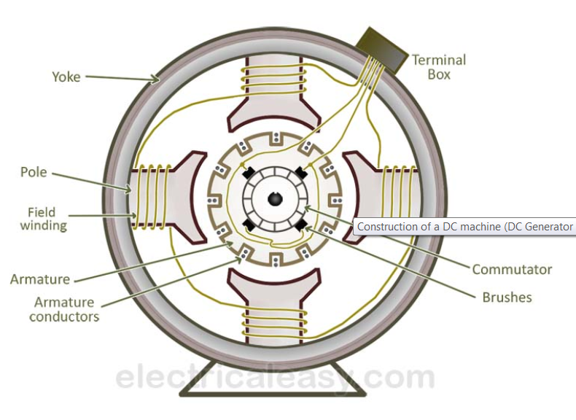

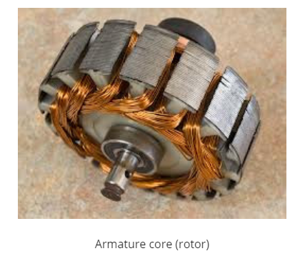

The above figure shows constructional details of a simple **4-pole DC machine**. A DC machine consists of two basic parts; stator and rotor. Basic constructional parts of a DC machine are described below.

1. **Yoke:** The outer frame of a dc machine is called as yoke. It is made up of cast iron or steel. It not only provides mechanical strength to the whole assembly but also carries the magnetic flux produced by the field winding.
2. **Poles and pole shoes:** Poles are joined to the yoke with the help of bolts or welding. They carry field winding and pole shoes are fastened to them. Pole shoes serve two purposes; (i) they support field coils and (ii) spread out the flux in air gap uniformly.
3. **Field winding:** They are usually made of copper. Field coils are former wound and placed on each pole and are connected in series. They are wound in such a way that, when energized, they form alternate North and South poles
4. **Armature core:** Armature core is the rotor of a dc machine. It is cylindrical in shape with slots to carry armature winding. The armature is built up of thin laminated circular steel disks for reducing eddy current losses. It may be provided with air ducts for the axial air flow for cooling purposes. Armature is keyed to the shaft.
5. [**Armature winding**](https://www.electricaleasy.com/2012/12/armature-winding-of-dc-machine.html)**:** It is usually a former wound copper coil which rests in armature slots. The armature conductors are insulated from each other and also from the armature core. Armature winding can be wound by one of the two methods; lap winding or wave winding. Double layer lap or wave windings are generally used. A double layer winding means that each armature slot will carry two different coils.
6. **Commutator and brushes:** Physical connection to the armature winding is made through a commutator-brush arrangement. The function of a commutator, in a dc generator, is to collect the current generated in armature conductors. Whereas, in case of a dc motor, commutator helps in providing current to the armature conductors. A commutator consists of a set of copper segments which are insulated from each other. The number of segments is equal to the number of armature coils. Each segment is connected to an armature coil and the commutator is keyed to the shaft. Brushes are usually made from carbon or graphite. They rest on commutator segments and slide on the segments when the commutator rotates keeping the physical contact to collect or supply the current.

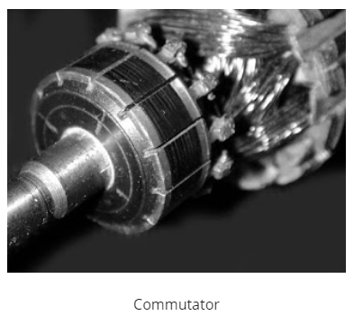

**CONSTRUCTION OF AC MACHINES (THREE PHASE INDUCTION MOTOR)**

The three-phase induction motor is the most widely used electrical motor. Almost 80% of the mechanical power used by industries is provided by three phase induction motors because of its simple and rugged construction, low cost, good operating characteristics, the absence of commutator and good speed regulation. In three phase induction motor, the power is transferred from stator to rotor winding through induction. The induction motor is also called a synchronous motor as it runs at a speed other than the synchronous speed.

Like any other electrical motor induction motor also have two main parts namely rotor and stator.

**Stator**: As its name indicates stator is a stationary part of induction motor. A stator winding is placed in the stator of induction motor and the three-phase supply is given to it.

**Rotor**: The rotor is a rotating part of induction motor. The rotor is connected to the mechanical load through the shaft.

The rotor of the three-phase induction motor are further classified as

* Squirrel cage rotor,
* Slip ring rotor or wound rotor or phase wound rotor.

### STATOR OF THREE PHASE INDUCTION MOTOR

The stator of the three-phase induction motor consists of three main parts:

1. Stator frame,
2. Stator core,
3. Stator winding or field winding.

**PARTS OF AC MOTOR (3-PHASE INDUCTION MOTOR)**

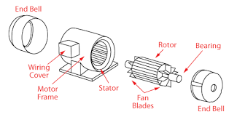

**3-Phase Induction Motor**

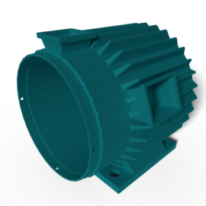

**STATOR FRAME**

### stator core

### STATOR CORE

### stator-winding

### STATOR WINDING OR FIELD WINDING

#### rotor of induction motor

#### SQUIRREL CAGE THREE PHASE INDUCTION MOTOR

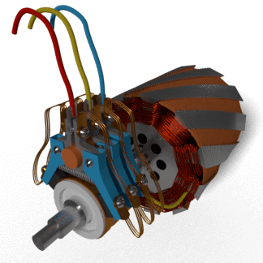

**SLIP RING OR WOUND ROTOR THREE PHASE INDUCTION MOTOR**

**POST-LAB QUESTIONS**

**1. Why we need starter for machines?**

**Ans : *Starters*** *are used to protect DC motors from damage that can be caused by very high current and torque during startup. They do this by providing external resistance to the motor, which is connected in series to the motor's armature winding and restricts the current to an acceptable level.*

**2. Name any four the domestic electrical machines with name-plate details.**

**Ans : i.** *DC Motor.*

**ii.** *Charger / Adapter.*

**iii.** *Refrigerator.*

**iv.** *Air Conditioner.*

**3. Difference between 3-phase squirrel cage and slip-ring induction motor?**

**Ans :**

| **Basis for Comparison** | **Slip-Ring Motor** | **Squirrel-Cage motor** |
| --- | --- | --- |
| *Definition* | *The rotor of the motor is constructed as a slip ring type.* | *The rotor of the motor is a squirrel cage type.* |
| *Rotor* | *Cylindrical laminated core with parallel slots and each slot consists one bar.* | *The slots of the rotor are not parallel, but are skewed.* |
| *Other-name* | *Phase wound rotor* | *Cage motor* |
| *Construction* | *Complicated* | *Simple* |
| *Resistance* | *Added external to the rotor* | *The rotor bar is permanently shorted at the end of the ring thus, it is not possible to add any external resistance.* |
| *Starter* | *The rotor resistance starter can be used.* | *Rotor resistance starter cannot be used.* |
| *Starting Torque* | *High* | *Low* |
| *Brushes* | *Present* | *Absent* |
| *Maintenance* | *Frequent maintenance required* | *Less maintenance required* |
| *Copper Loss* | *High* | *Low* |
| *Efficiency* | *Low* | *High* |
| *Speed Control* | *Possible* | *Not Possible* |
| *Power Factor* | *Low* | *High* |
| *Cost* | *Costly* | *Cheap* |
| *Starting Current* | *Low* | *High* |
| *Uses* | *Use in hoist, cranes, elevator where high torque is required.* | *Use in lathe machines, fan, blower, profiting machines, etc.* |

**4. What are the various types of rotors used in the alternators?**

**Ans :** *There are mainly two types of rotors used in construction of alternator:-*

**i.** *Salient pole type.*

**ii.** *Cylindrical rotor type.*

**5. What are the applications of DC motors?**

**Ans :**

